Week – 9

Two-Dimensional and Multi-Dimensional Arrays

Roll no: 240801162

Name: Keerthanaa Kumaraswamy

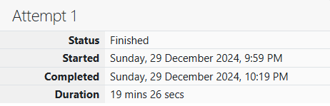

**Problem 1:**

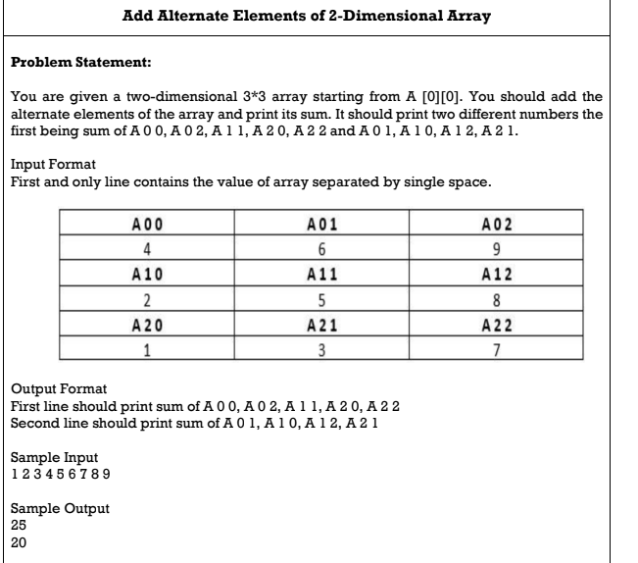

**Code**

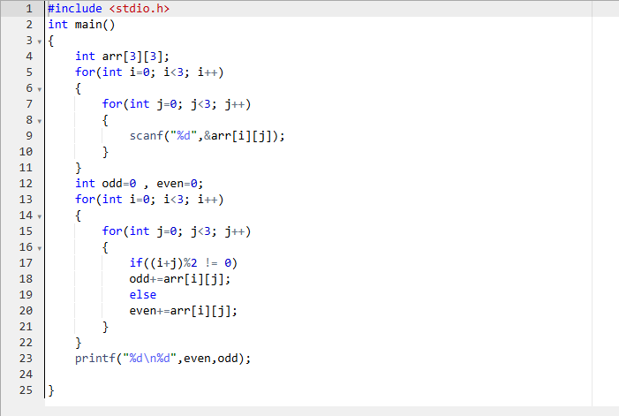

**OUTPUT:**

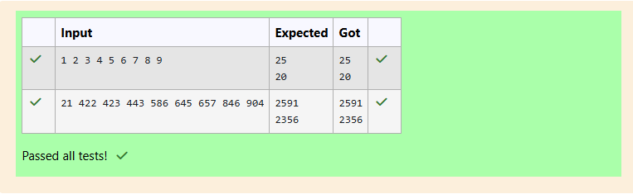

**Problem 2:**

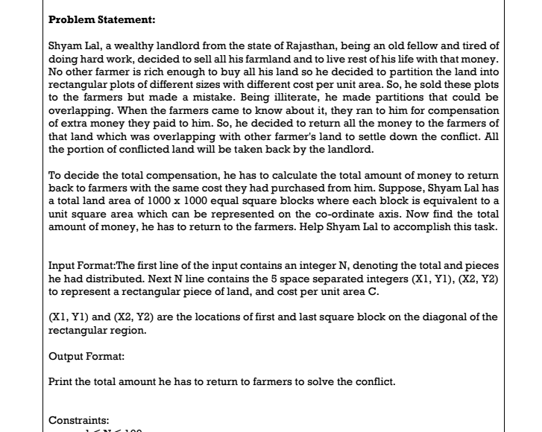

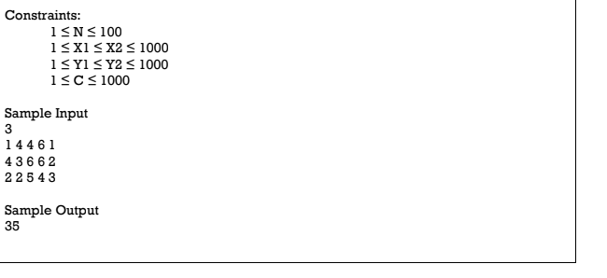

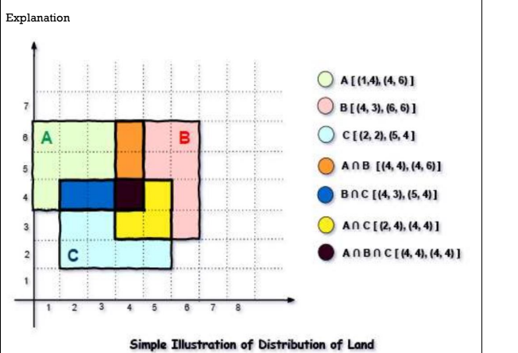

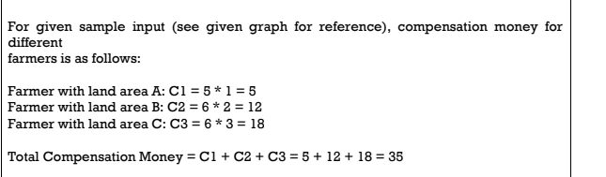

**Code:**

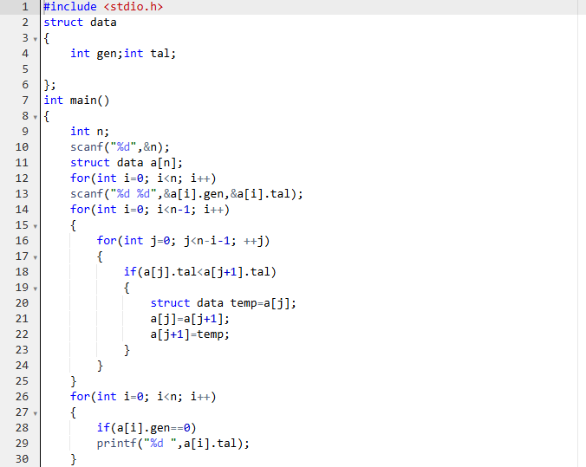

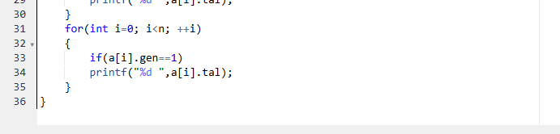

**OUTPUT:**

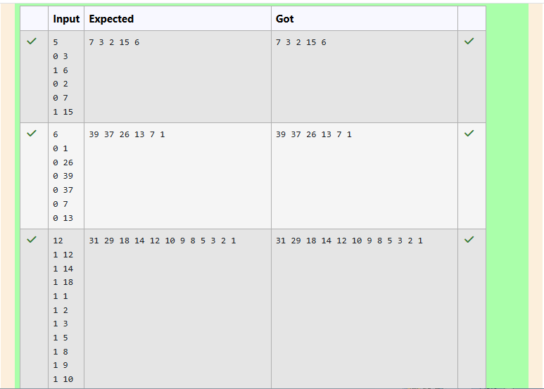

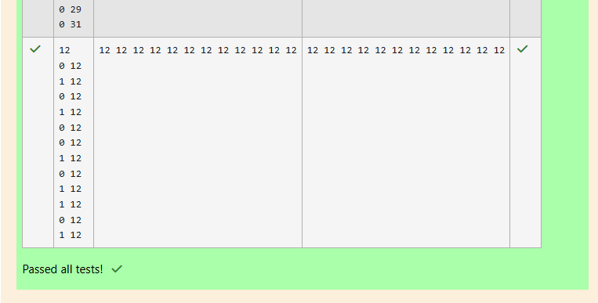

**Problem 3:** Microsoft has come to hire interns from your college. N students got shortlisted out of

which few were males and a few females. All the students have been assigned talent

levels. Smaller the talent level, lesser is your chance to be selected. Microsoft wants to

create the result list where it wants the candidates sorted according to their talent levels,

but there is a catch. This time Microsoft wants to hire female candidates first and then male

candidates. The task is to create a list where first all-female candidates are sorted in a

descending order and then male candidates are sorted in a descending order.

**Input Format**

The first line contains an integer N denoting the number of students. Next, N lines contain

two space-separated integers, ai and bi. The first integer, ai will be either 1(for a male

candidate) or 0(for female candidate). The second integer, bi will be the candidate's talent

level.

**Constraints: 1 <= N <= 105, 0 <= ai <= 1, 1 <= bi <= 109**

**Output Format**

Output space-separated integers, which first contains the talent levels of all female

candidates sorted in descending order and then the talent levels of male candidates in

descending order.

**Sample Input**

5

0 3

1 6

0 2

0 7

1 15

**Sample Output**

7 3 2 15 6

**Code:**

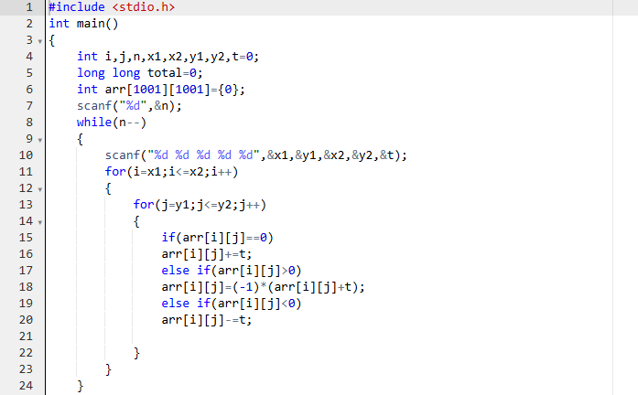

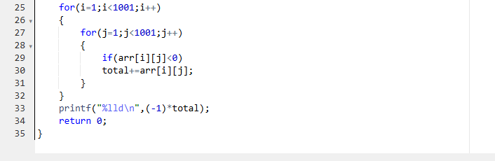

**OUTPUT:**

